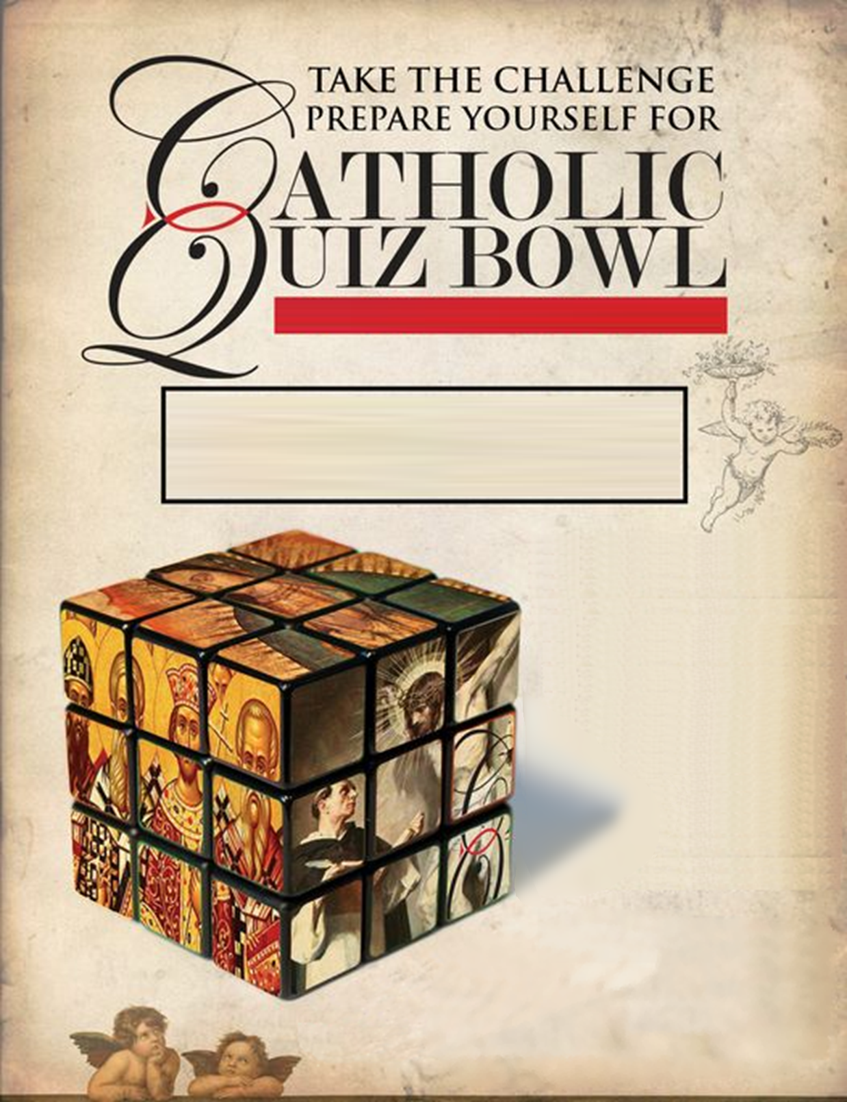

***WITH   
PAPA  
 JOHN’S  
 PIZZA!***

‘S

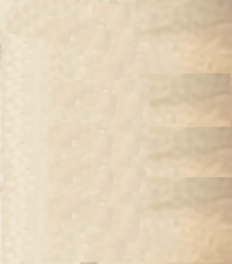

SAINT THOMAS MORE CATHOLIC CHURCH

SATURDAY MARCH 16TH

From 10am to ~12:30

(pizza to follow competition)

*TOPICS THIS YEAR: SAINTS / MIRACLES / MASS PARTS / CHURCH BUILDING / COLORS / NUMBERS / SEASONS*

* TO REGISTER, CONTACT  
   NATALIE COOK, 605-692-8309  
   coordinator@stmbrookings.org
* Please have your team checked-in and seated in the STM Social Hall before 10am
* MEDALS AWARDED TO   
  1ST, 2ND, & 3RD TEAMS
* FOUR ROUNDS
* For Middle school students registered in STM RE program

Sponsored by your local

Knights of Columbus, Council #3640

* TEAM COMPETITION

WITH 3 TO 6 PER TEAM